Zee music company analysis requirements
Dashboard Page 1 — Music Performance Overview
Requirements:
1.Identify the artist with the highest number of streams.
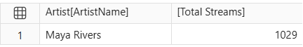

2.Display the top 10 artists based on total revenue.
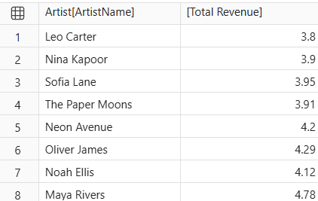

3.Compare the revenue generated by different genres.
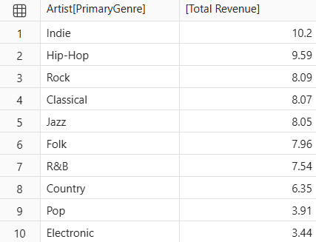

4.Identify the album with the highest listening activity.
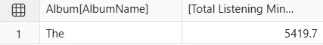

5. Analyse monthly stream trends.
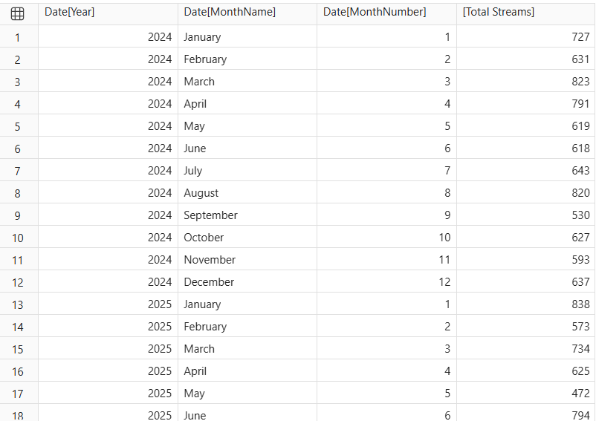
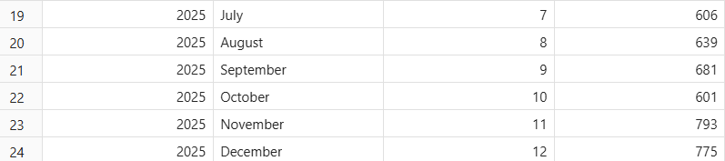

6. Compare revenue between 2024 and 2025.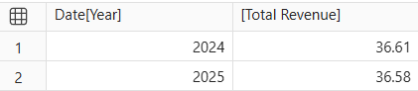

Dashboard Page 2 — Listener Behaviour and Revenue Analysis
Requirements:

1.Determine which subscription type generates the highest total revenue.
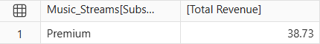

2. Compare the average revenue per record for each subscription type.
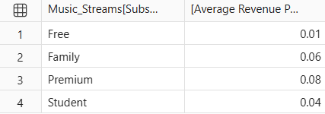

3. Identify which device accounts for the most streaming activity.
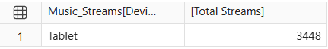

4. Compare listening behaviour across countries.
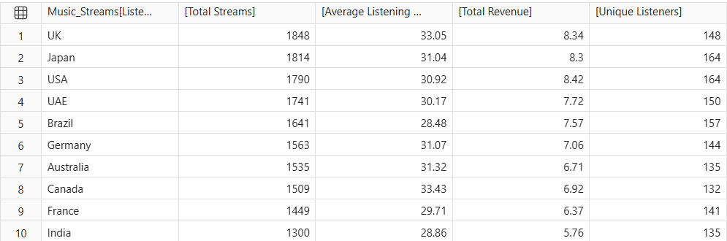

5. Find which playlist source has the highest number of streams.
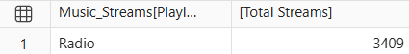

6. Compare completed and not-completed records.
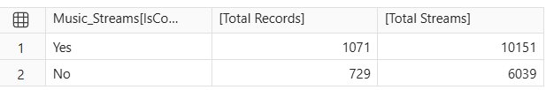

7. Analyse the relationship between Skip Count and Rating.
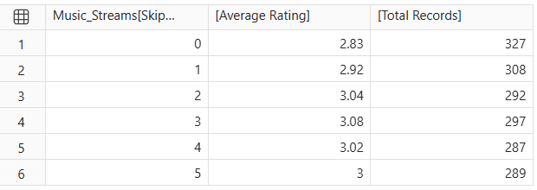

8. Compare revenue growth with the previous year.
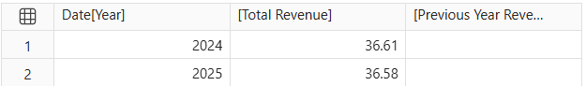

9. Identify artists or albums with high streams but relatively low revenue.


